Starting with php

1. Install wamp server and then launch it. It should display a trayicon W colored green.
2. To check if it is up and running, open the browser and type 127.0.0.1 or localhost

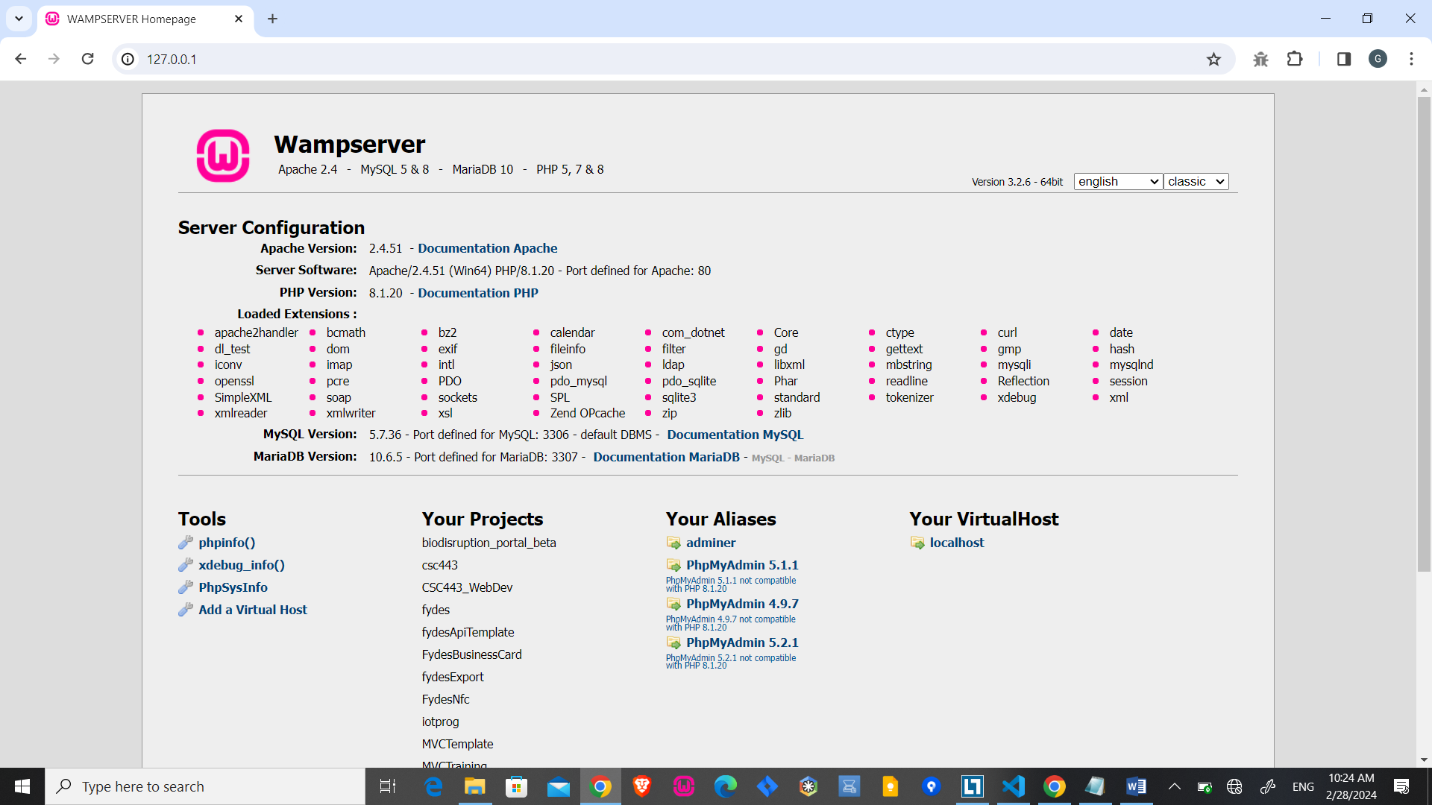

Figure . Wamp server page

1. it should display the wamp page
2. place your project folder inside the root folder of your web server. In this case inside folder "www" within the wamp folder

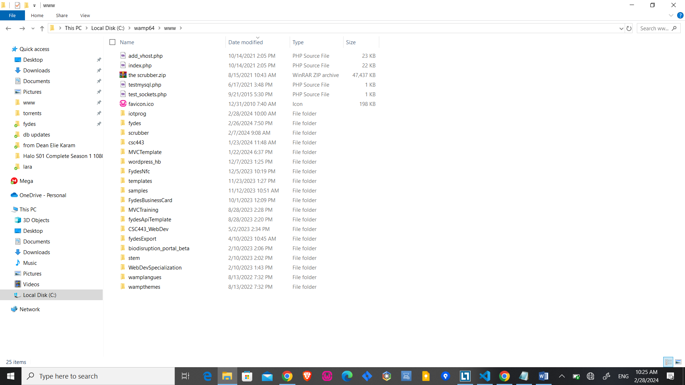

Figure .www folder with iotprog folder in it

1. add a php file to the main project folder call it “index.php”
2. write the following:

<?php

echo "hello from php";

?>

1. run the php file from within the server by typing the address of the file in the browser starting with ip 127.0.0.1 or localhost followed by the project folder name.

ex: <http://127.0.0.1/iotprog>

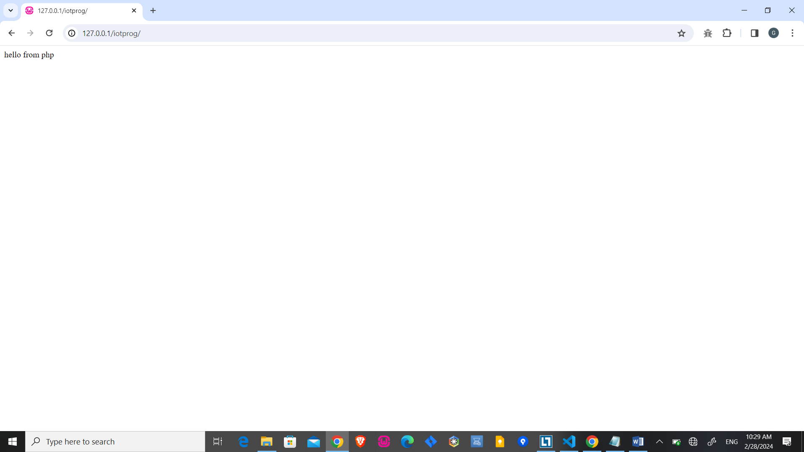

Figure .index.php running from the server